**ПРИЛОЖЕНИЕ А**

**Программный код файлов:**

**1.index.html**

<!DOCTYPE html>

<html lang="en">

<head>

<meta charset="UTF-8" />

<meta http-equiv="X-UA-Compatible" content="IE=edge" />

<meta name="viewport" content="width=device-width,initial-scale=1" />

<link rel="preconnect" href="https://fonts.googleapis.com" />

<link rel="preconnect" href="https://fonts.gstatic.com" crossorigin />

<link

href="https://fonts.googleapis.com/css2?family=Poppins&display=swap"

rel="stylesheet"

/>

<link href="./css/reset.css" rel="stylesheet" />

<link href="./css/normalize.css" rel="stylesheet" />

<link href="./css/base.css" rel="stylesheet" />

<link href="./css/header.css" rel="stylesheet" />

<link href="./css/box1.css" rel="stylesheet" />

<link href="./css/box2.css" rel="stylesheet" />

<link href="./css/box3.css" rel="stylesheet" />

<link href="./css/box4.css" rel="stylesheet" />

<link href="./css/box5.css" rel="stylesheet" />

<link href="./css/box6.css" rel="stylesheet" />

<link href="./css/box7.css" rel="stylesheet" />

<link href="./css/box8.css" rel="stylesheet" />

<link href="./css/box9.css" rel="stylesheet" />

<link href="./css/box10.css" rel="stylesheet" />

<link href="./css/footer.css" rel="stylesheet" />

<link href="./css/adaptation.css" rel="stylesheet" />

<title>Wishbone</title>

<script src="./js/jquery.js"></script>

<script src="./js/main.js"></script>

</head>

<body>

<div class="container">

<header class="header">

<div class="header__row">

<div class="header__logo">

<img src="./images/logo.svg" alt="logo" />

</div>

<nav class="header__nav">

<button class="header__nav-btn">

<span class="header__ nav-btn span"></span>

</button>

<ul class="header__nav-ul">

<li class="header__nav-li"><a href="#">Projects</a></li>

<li class="header__nav-li"><a href="#">About</a></li>

<li class="header__nav-li"><a href="#">News</a></li>

<li class="header__nav-li"><a href="#">Team</a></li>

<li class="header__nav-li"><a href="#">Contact</a></li>

<li>

<div class="header__template">

<a href="#" class="btn">Get template</a>

</div>

</li>

</ul>

</nav>

</div>

</header>

</div>

<div class="container">

<div class="box1__container-box1">

<div class="box1__content-box-first">

<p class="box1__title">Wishbone+Partners</p>

<h1 class="box1__head">The home of beautiful architecture.</h1>

<p class="box1__text">

We are an architecture firm with a focus on beautiful but functional

design. At its heart, we believe design is about usability and

accessibility — these are the guiding principles for our work. Read

more about our previous projects, our process and our team below.

</p>

<a href="#" class="box1__read">Read more</a>

</div>

<div class="box1__img"><img src="./images/main-one.jpg" alt=""></div>

</div>

</div>

<div class="container">

<div class="box2_content">

<div class="box2__text">

<div class="box2__header">

<ul class="box2__header-spisok">

<li class="box2__header-li"><p>Our firm</p></li>

</ul>

</div>

<ul class="box2__text-random">

<li class="box2__spisok">

<p>

Lorem ipsum dolor sit amet, consectetur adipiscing elit.

Suspendisse varius enim in eros elementum tristique. Duis

cursus, mi quis viverra ornare, eros dolor interdum nulla, ut

commodo diam libero vitae erat. Aenean faucibus nibh et justo

cursus id rutrum lorem imperdiet. Nunc ut sem vitae risus

tristique posuere.

</p>

</li>

<li class="box2__spisok">

<p>

Lorem ipsum dolor sit amet, consectetur adipiscing elit.

Suspendisse varius enim in eros elementum tristique. Duis

cursus, mi quis viverra ornare, eros dolor interdum nulla, ut

commodo diam libero vitae erat. Aenean faucibus nibh et justo

cursus id rutrum lorem imperdiet. Nunc ut sem vitae risus

tristique posuere.

</p>

</li>

<li class="box2__spisok">

<p>

Lorem ipsum dolor sit amet, consectetur adipiscing elit.

Suspendisse varius enim in eros elementum tristique. Duis

cursus, mi quis viverra ornare, eros dolor interdum nulla, ut

commodo diam libero vitae erat. Aenean faucibus nibh et justo

cursus id rutrum lorem imperdiet. Nunc ut sem vitae risus

tristique posuere.

</p>

</li>

<li class="box2_spisok">

<div class="box2__icon-names">

<img

class="box2__stephen-icon"

src="./images/stephen-collier.png"

alt="photo"

/>

<div class="box2__stephen-icon-text">

<p class="box2__stephen">Stephen Collier</p>

<p class="box2__stephen rank">Senior Partner</p>

</div>

</div>

</li>

</ul>

</div>

</div>

</div>

<div class="container">

<div class="box3__content">

<div class="box3__text">

<ul class="box3__text-reed">

<li class="box3__reed-random"><p>Reeding House</p></li>

<li class="box3__reed-main">

<p>Lorem ipsum dolor sit amet, dolor sit amet dolor sit amet.</p>

</li>

</ul>

</div>

</div>

</div>

<div class="container">

<div class="box4__content-box">

<div class="box4__header-box">

<p class="box4__header-fix-first">Our process</p>

<p class="box4__header-fix-second">How we do what we do.</p>

</div>

<div class="box4__elements">

<div class="box4__first-element">

<ul class="box4__first-content">

<li class="box4__first-spisok">

<img src="./images/icon-pero.png" alt="" />

</li>

<li class="box4__first-spisok">

<p class="box4__first-header">Sketching</p>

</li>

<li class="box4__first-spisok">

<p class="box4__first-main">

Lorem ipsum dolor sit amet, consectetur adipiscing elit. Nulla

ut tristique libero. Nulla luctus sapien ac arcu tempor, vitae

tempor leo iaculis.

</p>

</li>

</ul>

</div>

<div class="box4__second-element">

<ul class="box4__second-content">

<li class="box4__second-spisok">

<img src="./images/icon-lineika.png" alt="" />

</li>

<li class="box4__second-spisok"><p>Finalizing</p></li>

<li class="box4__second-spisok">

<p class="box4__second-main">

Adipiscing elit. Nulla ut tristique libero. Nulla vitae tempor

leo iaculis luctus sapien ac arcu tempor, vitae.

</p>

</li>

</ul>

</div>

<div class="box4__third-element">

<ul class="box4__third-content">

<li class="box4__third-spisok">

<img src="./images/icon-dom.png" alt="" />

</li>

<li class="box4__third-spisok"><p>Building</p></li>

<li class="box4__third-spisok">

<p class="box4__third-main">

Nulla ut tristique libero. Lorem ipsum ut tristique libero.

Nulla luctus sapien ac arcu tempor, vitae lorem ipsum dolor

leo iaculis.

</p>

</li>

</ul>

</div>

</div>

</div>

<div class="container">

<div class="box5__content">

<div class="box5__text">

<ul class="box5__text-marble">

<li class="box5__marble-random"><p>The marble staircase</p></li>

<li class="box5__marble-main">

<p>

Lorem ipsum dolor sit amet, dolor sit amet dolor sit amet.

</p>

</li>

</ul>

</div>

</div>

</div>

<div class="container">

<div class="box6__content">

<div class="box6__content-first">

<div class="box6__text">

<ul class="box6__spisok">

<li class="box6__spisok-text">

<p class="box6__header">prior clients</p>

</li>

<li class="box6__spisok-text">

<p class="box6__podheader">Happy customers.</p>

</li>

<li class="box6__spisok-text">

<p class="box6__main-text">

Morbi neque ex, condimentum dapibus congue et, vulputate ut

ligula. Vestibulum sit amet urna turpis. Mauris euismod elit

et nisi ultrices, ut faucibus orci tincidunt.

</p>

</li>

</ul>

</div>

</div>

<div class="box6__content-second">

<div class="box6__imgs">

<div class="box6__hill">

<img src="./images/hill-players.svg" alt="#" />

</div>

<div class="riskgransen">

<img src="./images/riksharnsen.svg" alt="#" />

</div>

<div class="box6__studio">

<img src="./images/studiocai.svg" alt="#" />

</div>

<div class="chill">

<img src="./images/chillindustried.svg" alt="#" />

</div>

</div>

</div>

</div>

</div>

<div class="container">

<div class="box7__content">

<div class="box7__text">

<ul class="box7__text-stair">

<li class="box7__stair-random"><p>The swirling staircase</p></li>

<li class="box7__stair-main">

<p>

Lorem ipsum dolor sit amet, dolor sit amet dolor sit amet.

</p>

</li>

</ul>

</div>

</div>

</div>

<div class="container">

<div class="box8__container-box">

<div class="box8__content">

<div class="box8__text-header">

<ul class="box8__header-main">

<li class="box8__spisok">

<p class="box8__head-text">Featured projects</p>

</li>

<li class="box8__spisok">

<p class="box8__text-main">

Some of the latest and greatest projects from us here at

Wishbone+Partners.

</p>

</li>

</ul>

</div>

<div class="box8__images-projects">

<img class="box8__no-view-adapt" src="./images/projects-1.jpg" alt="" />

<div class="box8__image-texts">

<ul class="box8__img-text">

<li class="box8__spisok">

<p class="box8__header-img-text">New York</p>

</li>

<li class="box8__spisok">

<p class="box8__img-main-text">Big Road Brewery</p>

</li>

</ul>

<div class="box8__img-rectangle">

<a href="#" class="box8__img-rectangle-link">Read more</a>

</div>

</div>

<img class="box8__img-adapt" src="./images/projects-3.jpg" alt="" />

</div>

<div class="box8__link-footer">

<a href="#" class="box8__link">View all projects</a>

</div>

</div>

</div>

</div>

<div class="container">

<div class="box9__container-box">

<div class="box9__content">

<div class="box9__text">

<p class="box9__meet-team">Meet our team</p>

<p class="box9__text-fish">

Lorem ipsum dolor sit amet, consectetur adipiscing elit.

Suspendisse varius enim in eros elementum tristique. Duis

cursus, mi quis.

</p>

<a class="box9__text-link" href="#">See team</a>

</div>

<div class="box9__img-staff">

<div class="box9__staff-boxs1"><ul>

<li>

<p class="box9__name1">Stephen Collier</p>

</li>

<li>

<p class="box9__rank1">Senior Partner</p>

</li>

</ul></div>

<div class="box9__staff-boxs3"><ul>

<li>

<p class="box9__name3">Nolan Peters</p>

</li>

<li>

<p class="box9__rank3">Associate</p>

</li>

</ul></div>

<div class="box9__staff-boxs2"><ul>

<li>

<p class="box9__name2">Ferris Wonder</p>

</li>

<li>

<p class="box9__rank2">Associate Partner</p>

</li>

</ul></div>

<div class="box9__staff-boxs5"><ul>

<li>

<p class="box9__name5">Aria Stone</p>

</li>

<li>

<p class="box9__rank5">Senior Partner</p>

</li>

</ul></div>

<div class="box9__staff-boxs4"><ul>

<li>

<p class="box9__name4">Niko Ferry</p>

</li>

<li>

<p class="box9__rank4">Partner</p>

</li>

</ul></div>

</div>

</div>

</div>

<div class="container">

<div class="box10__container-box">

<div class="box10__content">

<ul class="box10__get-touch">

<li class="box10__spisok">

<p class="box10__head-text">Get in touch</p>

</li>

<li class="box10__spisok">

<p class="box10__main-text">Think we would be a good fit for your next project?</p>

</li>

</ul>

<div class="box10__link">

<a class="box10__in-touch" href="#">Get in touch</a>

</div>

</div>

</div>

</div>

<footer class="footer">

<div class="container">

<div class="footer__container-box">

<div class="footer__content-box">

<div class="footer__content-box-left">

<ul class="footer__icon-text">

<li class="footer__spisok">

<img src="./images/logo.svg" alt="">

</li>

<li class="footer__spisok">

<p>Powered by Webflow.</p>

</li>

<li class="footer__spisok">

<p>All rights reserved Wishbone+Partners, Inc.

<a class="footer__license" href="#">Licensing.</a>

</li>

</ul>

</div>

<div class="footer__content-box-right">

<a href="#"><img class="footer__twitter" src="./images/twitter.png" alt="">

</a>

<a href="#"><img class="footer__inst" src="./images/inst.png" alt=""></a>

<a href="#"><img class="footer__fb" src="./images/fb.png" alt=""></a>

</div>

</div>

</div>

</div>

</footer>

</body>

</html>

**ПРИЛОЖЕНИЕ Б**

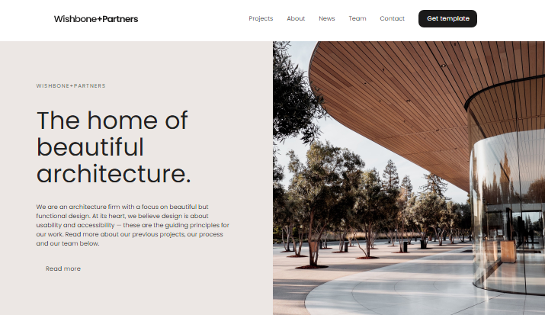**Отображение сайта в браузере**

Рисунок 2 — Скриншот с браузера ч.1

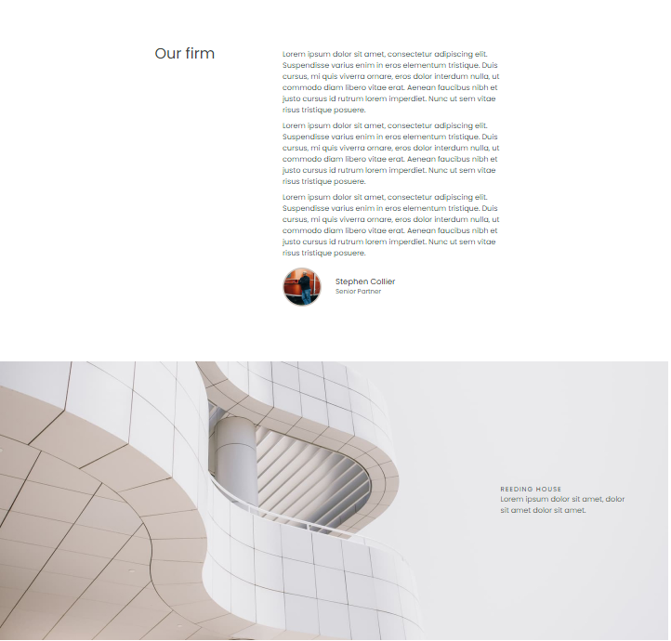

Рисунок 3 — Скриншот с браузера ч.2

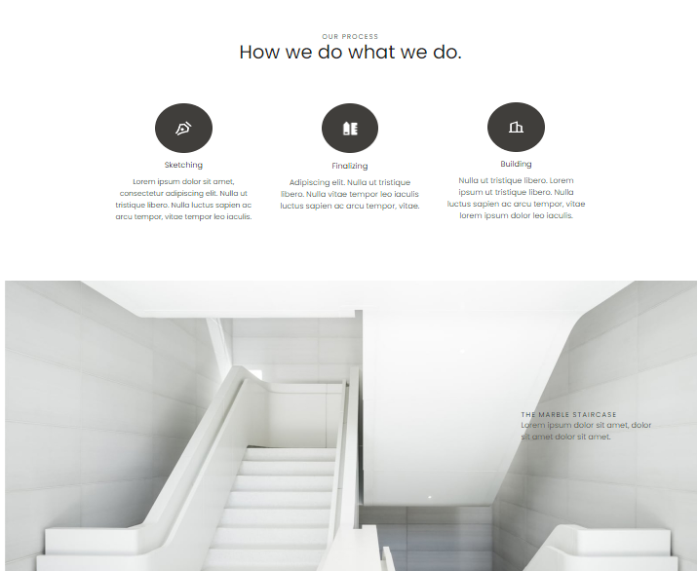

Рисунок 4 — Скриншот с браузера ч.3

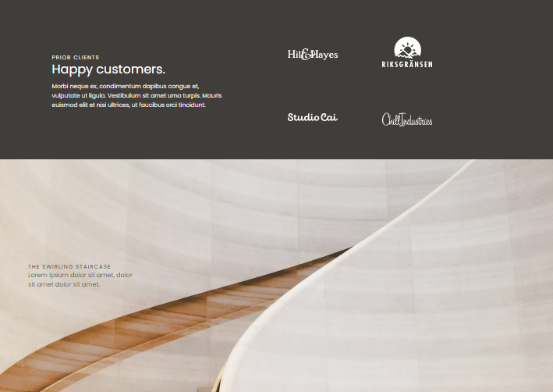

Рисунок 5 — Скриншот с браузера ч.4

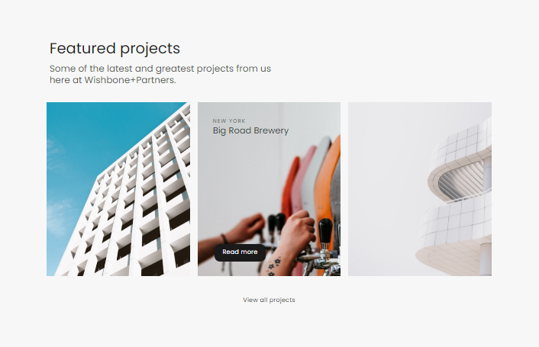

Рисунок 6 — Скриншот с браузера ч.5

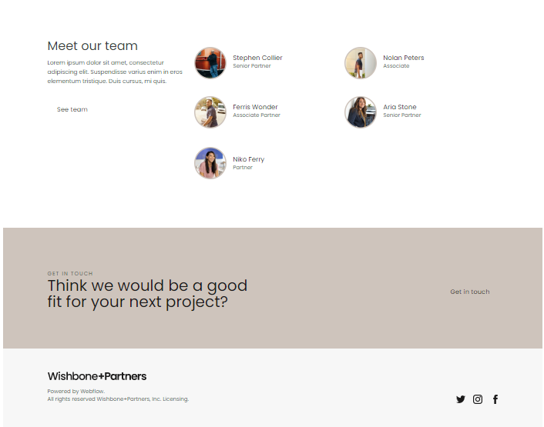

Рисунок 7 — Скриншот с браузера ч.6

Рисунок 10 – Скриншот с мобильного браузера Safar

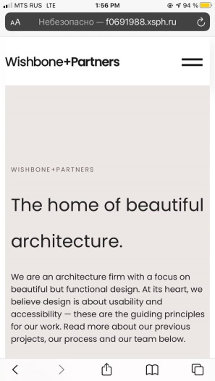

Рисунок 11 — Репозиторий в Github

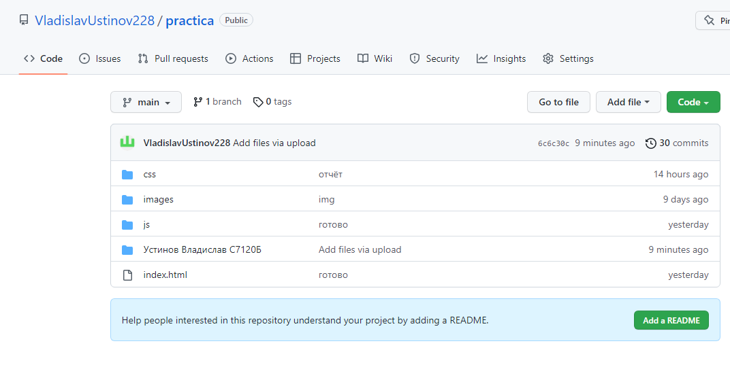

Рисунок 11 — Файловый менеджер

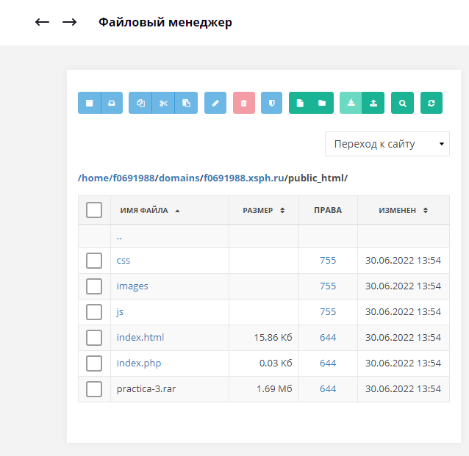

**ПРИЛОЖЕНИЕ В**

